Submitted by: Taha Saifee
Everything below ran on my laptop, on a small Hadoop + Hive cluster in Docker: a NameNode and a DataNode (HDFS), a ResourceManager and a NodeManager (YARN), a job history server and HiveServer2. The MapReduce programs are Python scripts run with Hadoop Streaming. All the scripts are in the part1_hadoop_hive folder of the project.
HADOOP

- Data Ingestion:
- Create a directory in HDFS and transfer the banking dataset from the local system to the HDFS directory.
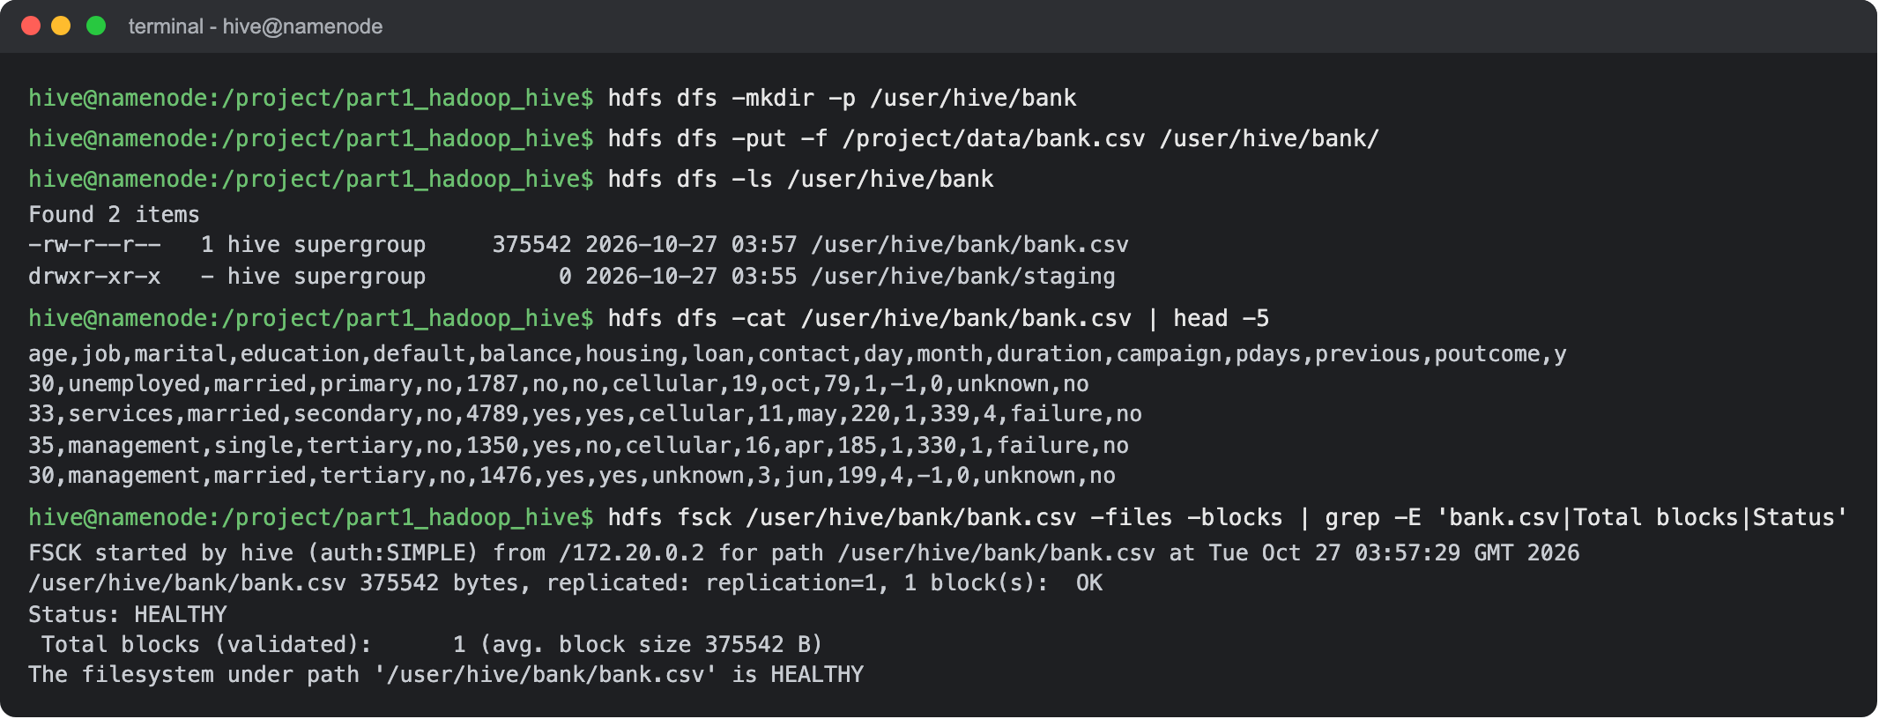
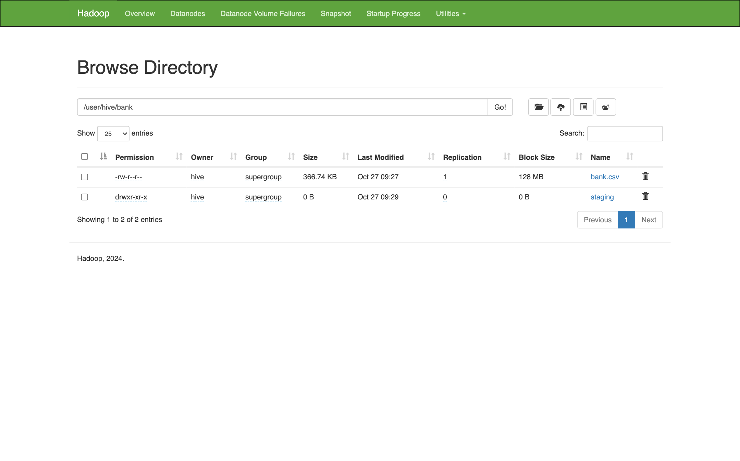
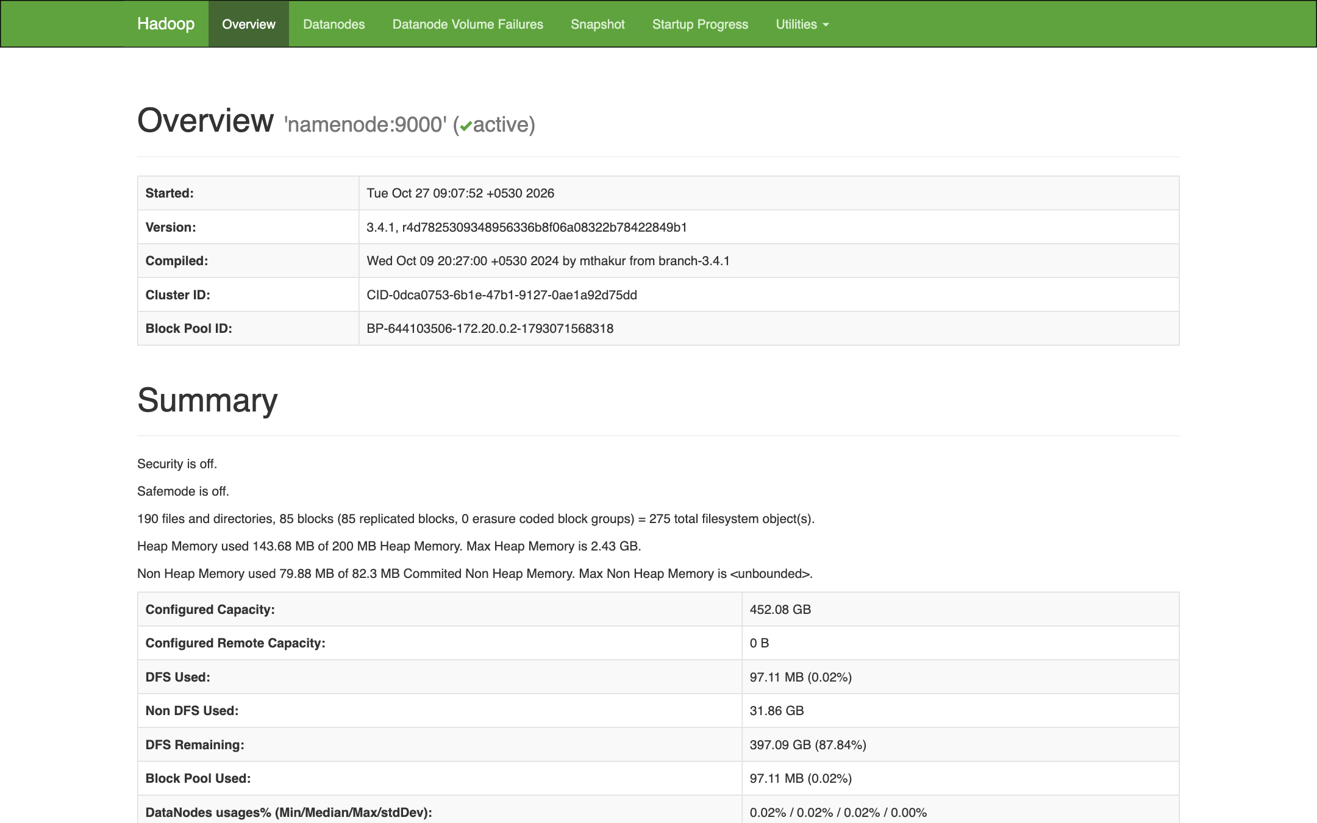
Result: I created /user/hive/bank in HDFS and copied bank.csv from my local folder into it with hdfs dfs -put. The listing, the first lines of the file and fsck show it is stored in HDFS: 375,542 bytes in 1 block, replication 1 because my cluster has one datanode. The NameNode web page shows the file and the live datanode.
- Data Transformation with MapReduce:
- Write a MapReduce program in Python that calculates the average account balance for each job type.
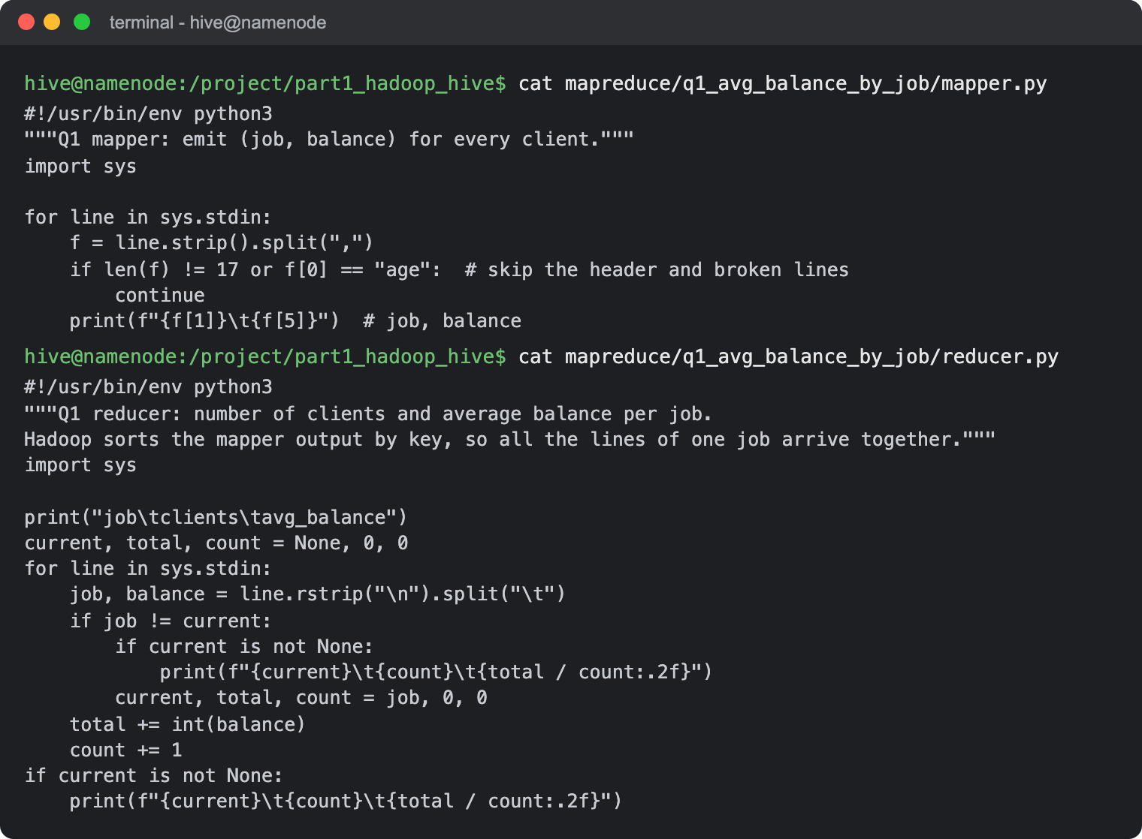
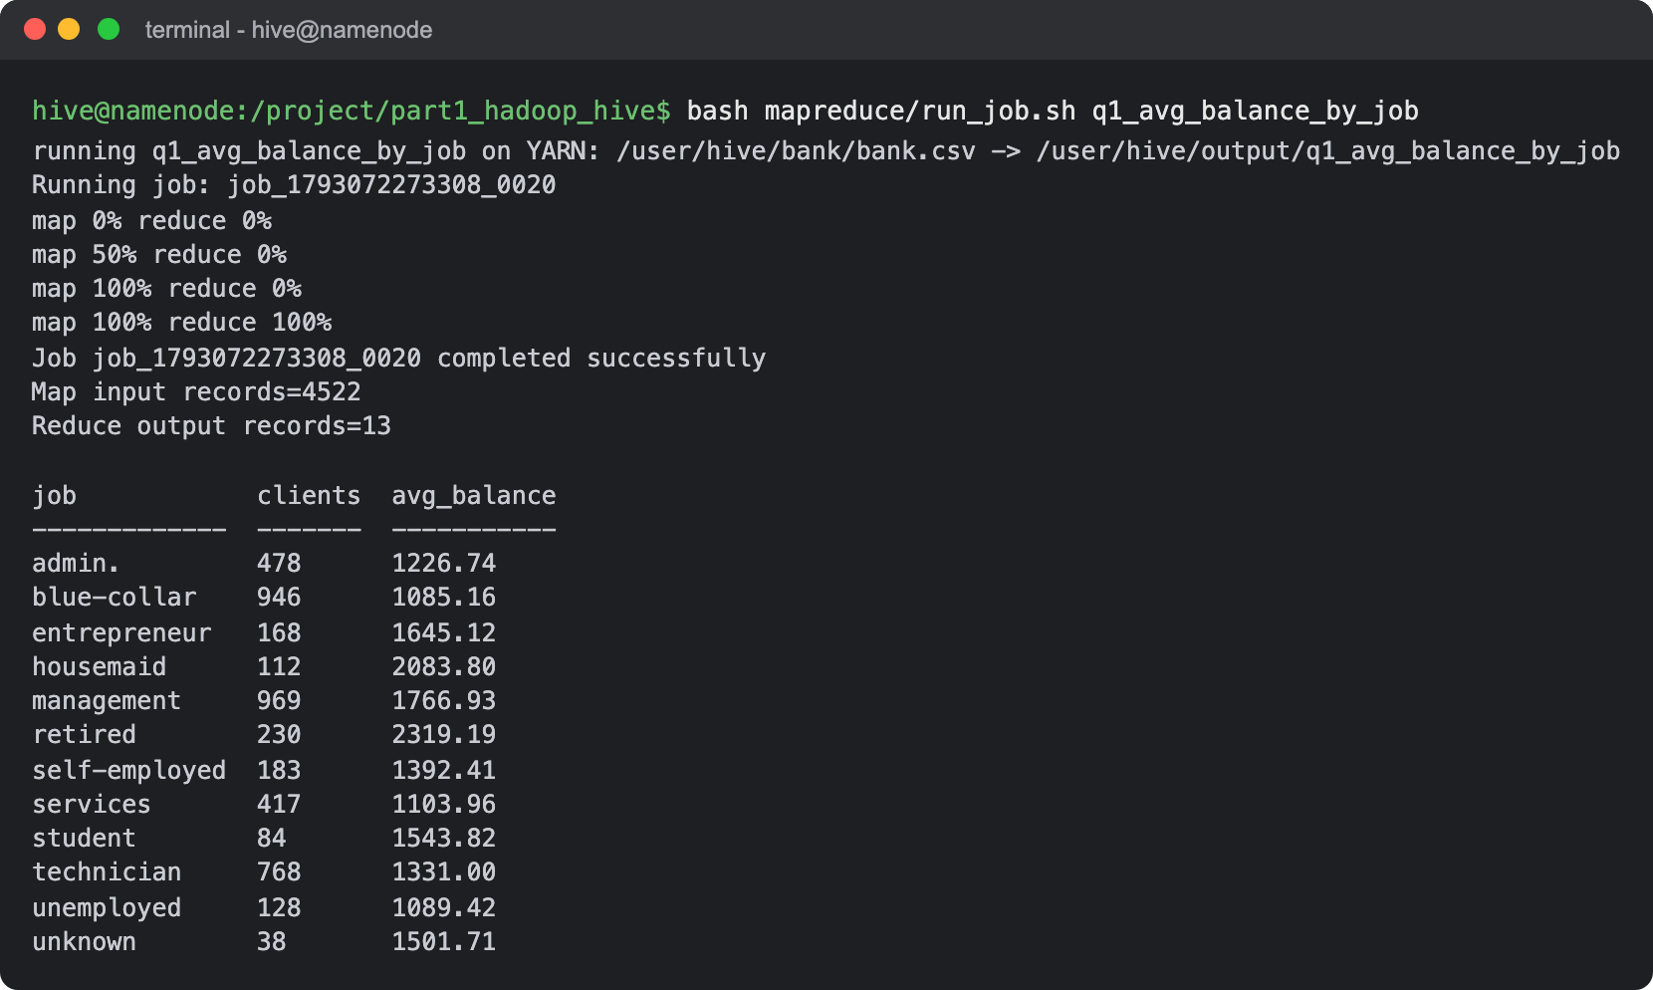
Result: Retired clients have the highest average balance (2,319), then housemaids (2,084) and management (1,767). Blue-collar, services and unemployed clients have the lowest, between 1,085 and 1,104.
- Write another MapReduce program that counts the number of individuals with and without a housing loan in each education category.
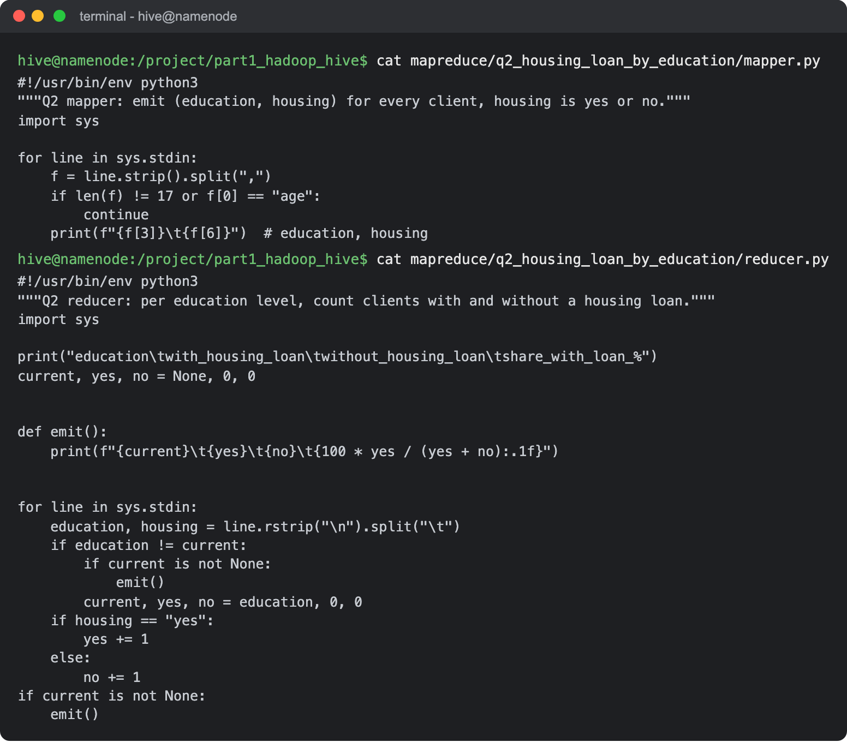
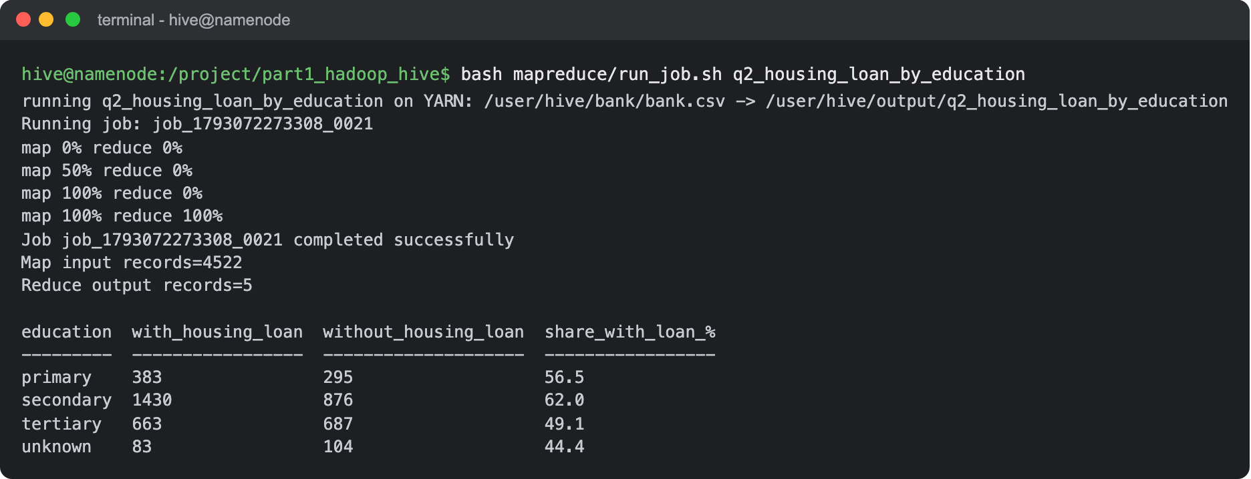
Result: Clients with secondary education have the most housing loans (1,430, which is 62% of that group). Tertiary is almost even (663 with a loan, 687 without) and primary is at 56.5%.
- Perform a MapReduce job to determine the number of clients contacted in each month and their subscription status to term deposits ('y' column).
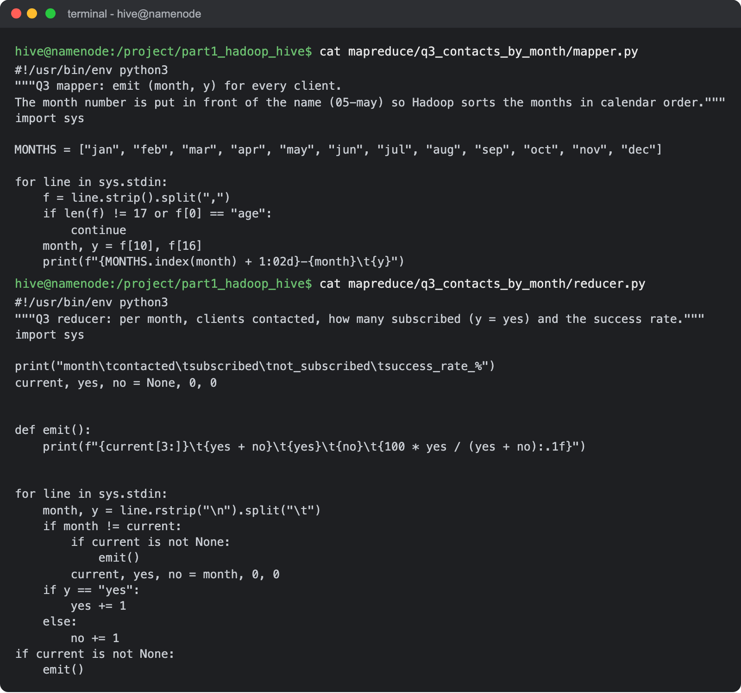
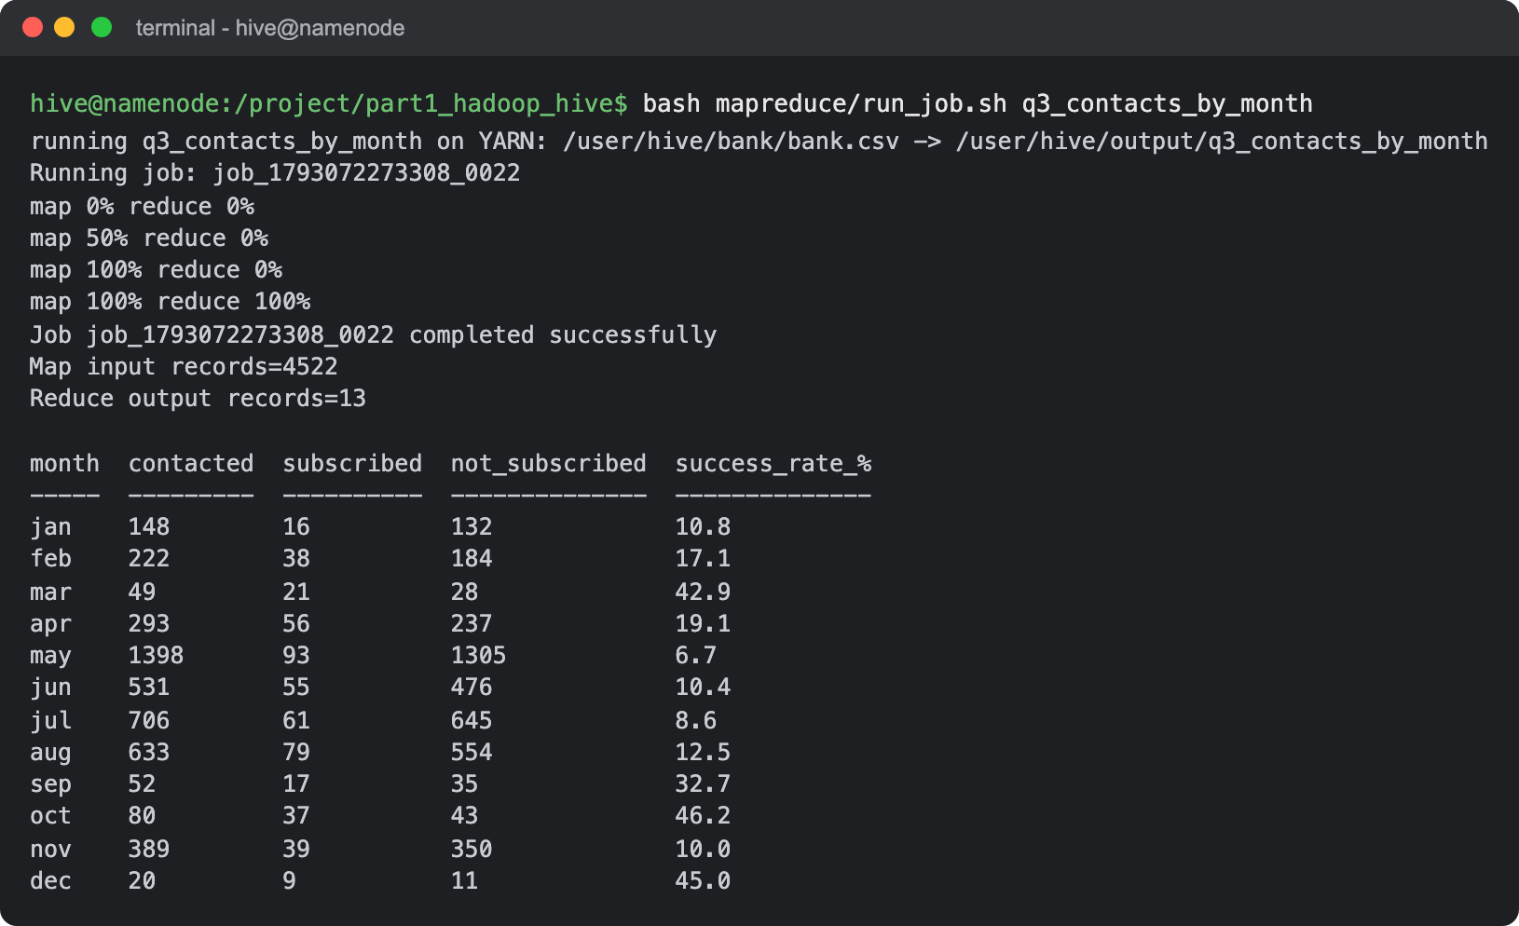
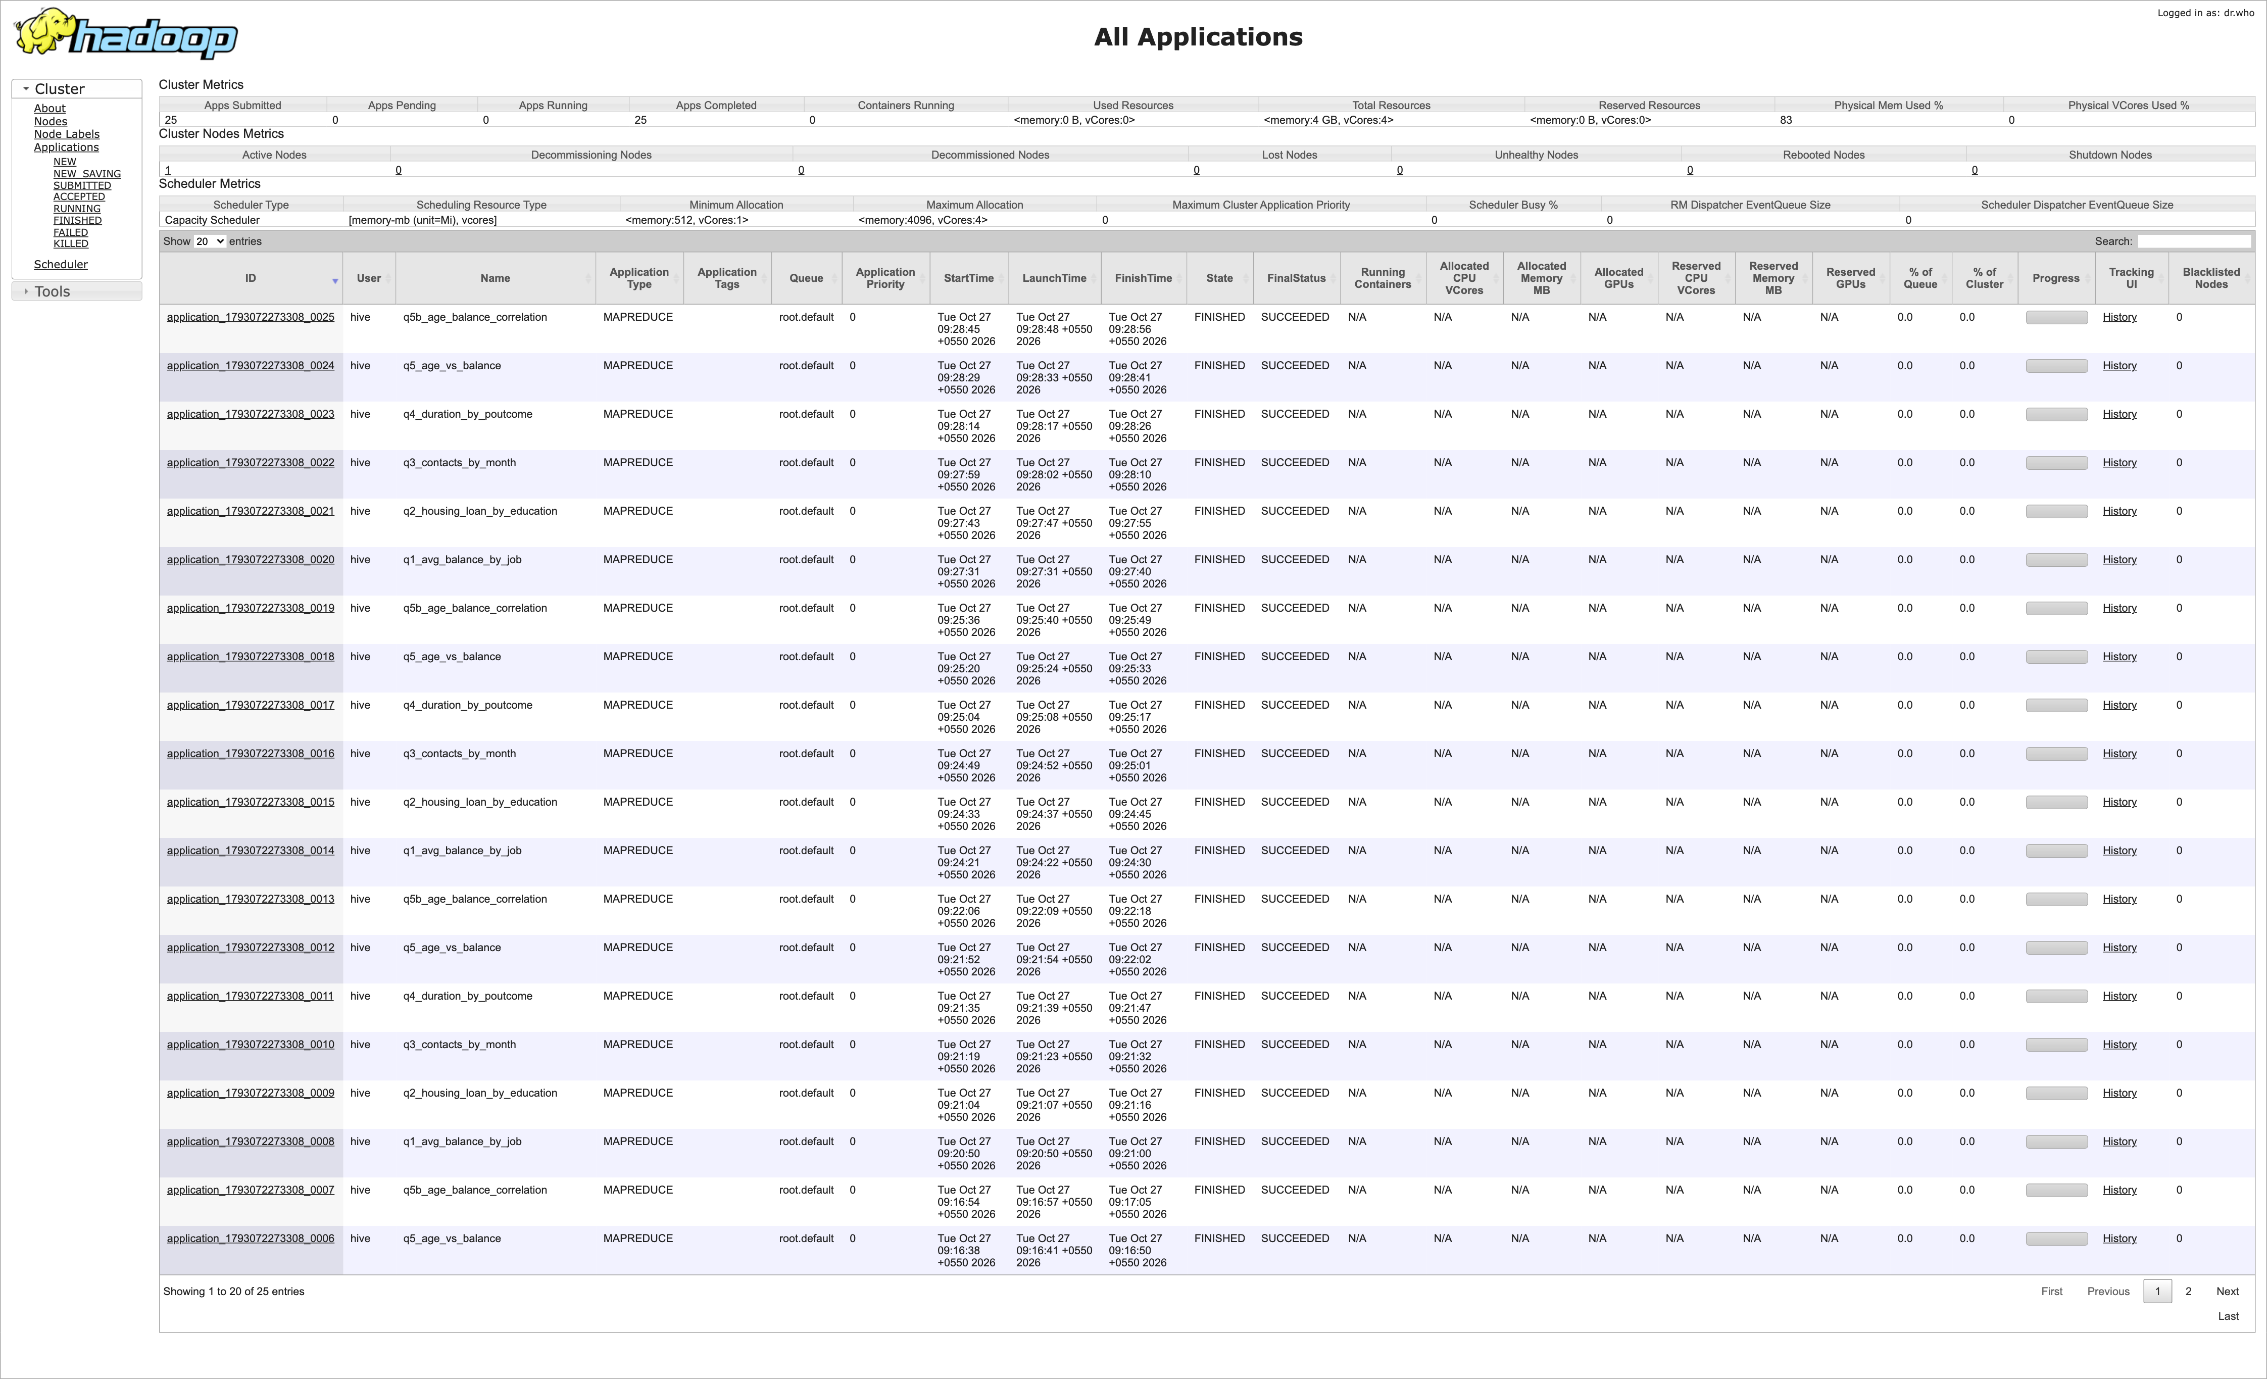
Result: May has by far the most contacts (1,398) but the lowest success rate (6.7%). The months with few contacts (March, September, October, December) convert between 33% and 46% of the clients. The YARN page shows all my MapReduce jobs finished with status SUCCEEDED.
- Data Analysis with MapReduce:
- Analyze the average duration of contact (in seconds) per campaign outcome ('poutcome').
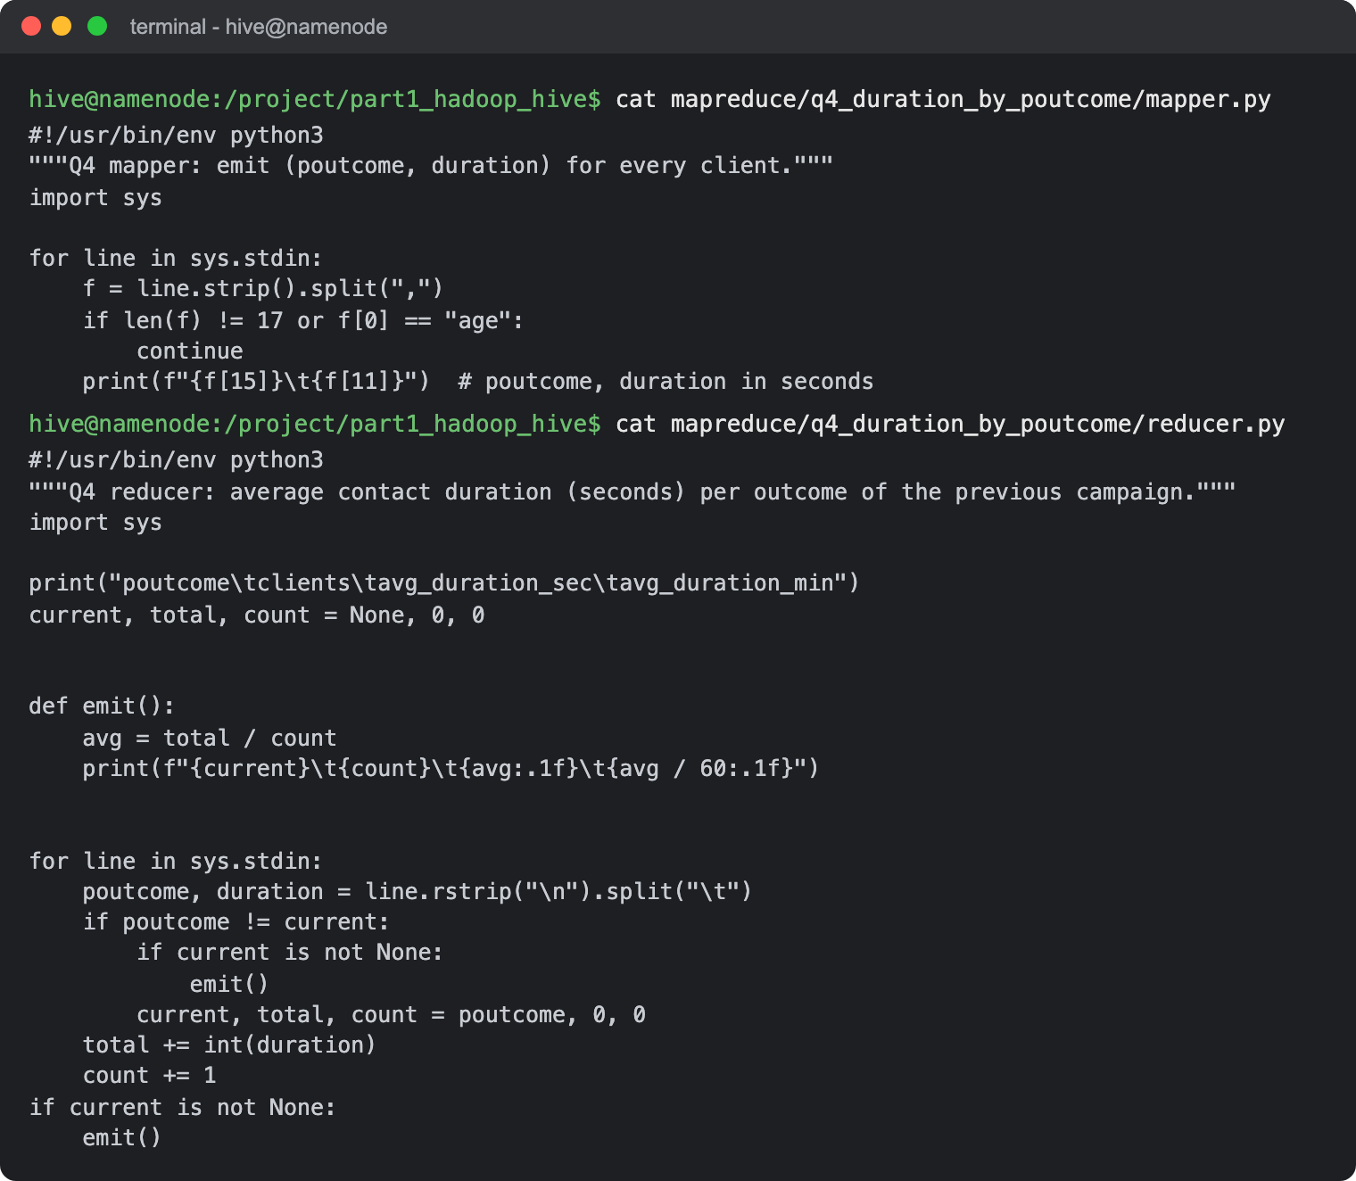
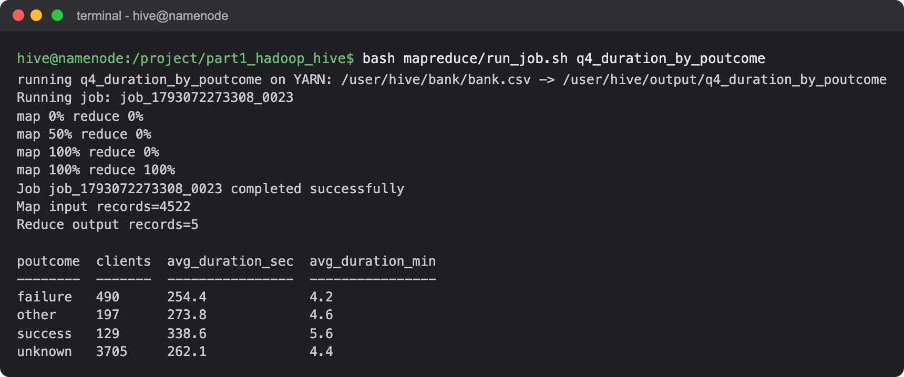
Result: Clients whose previous campaign was a success had the longest calls: 338.6 seconds (5.6 minutes) on average, against 254.4 seconds after a failure and about 262 seconds for clients never contacted before (unknown).
- Examine the relationship between the age of clients and their balance, and present findings in a summarized form.
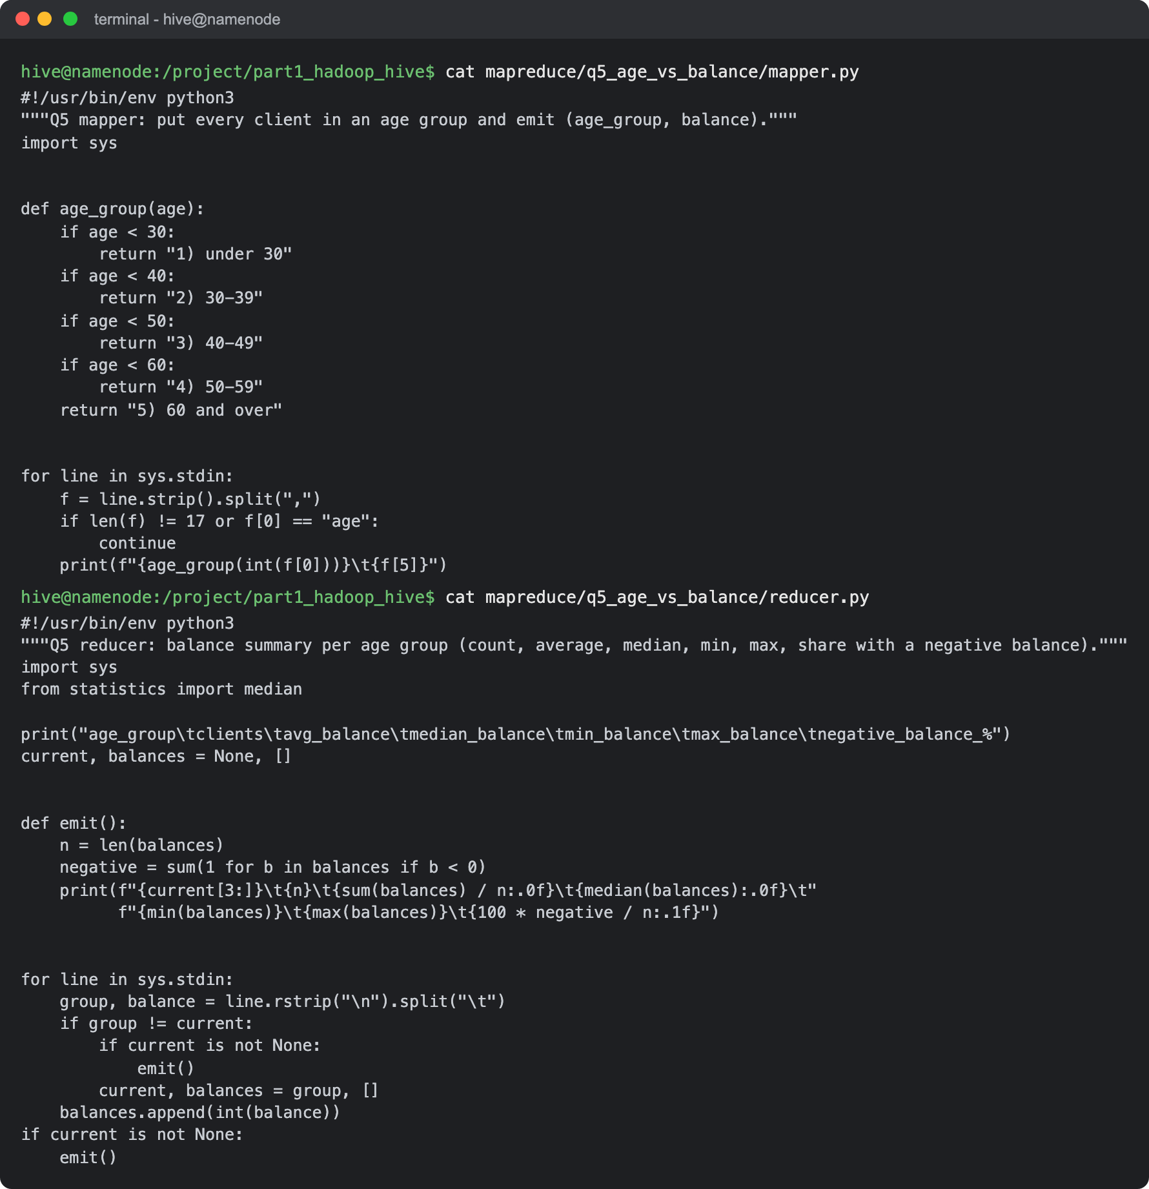
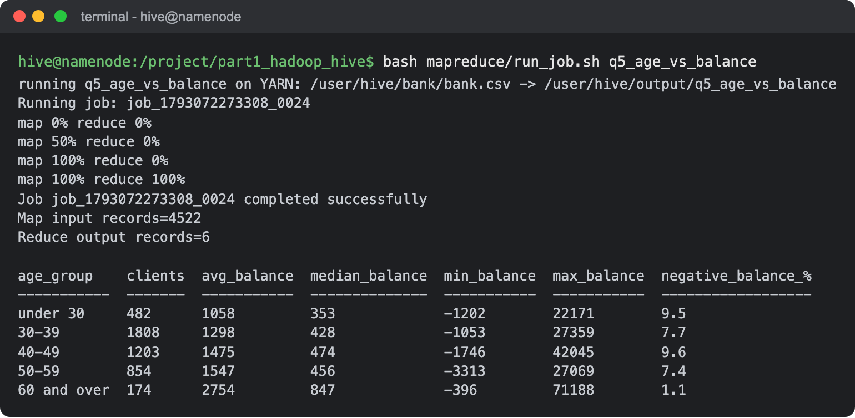
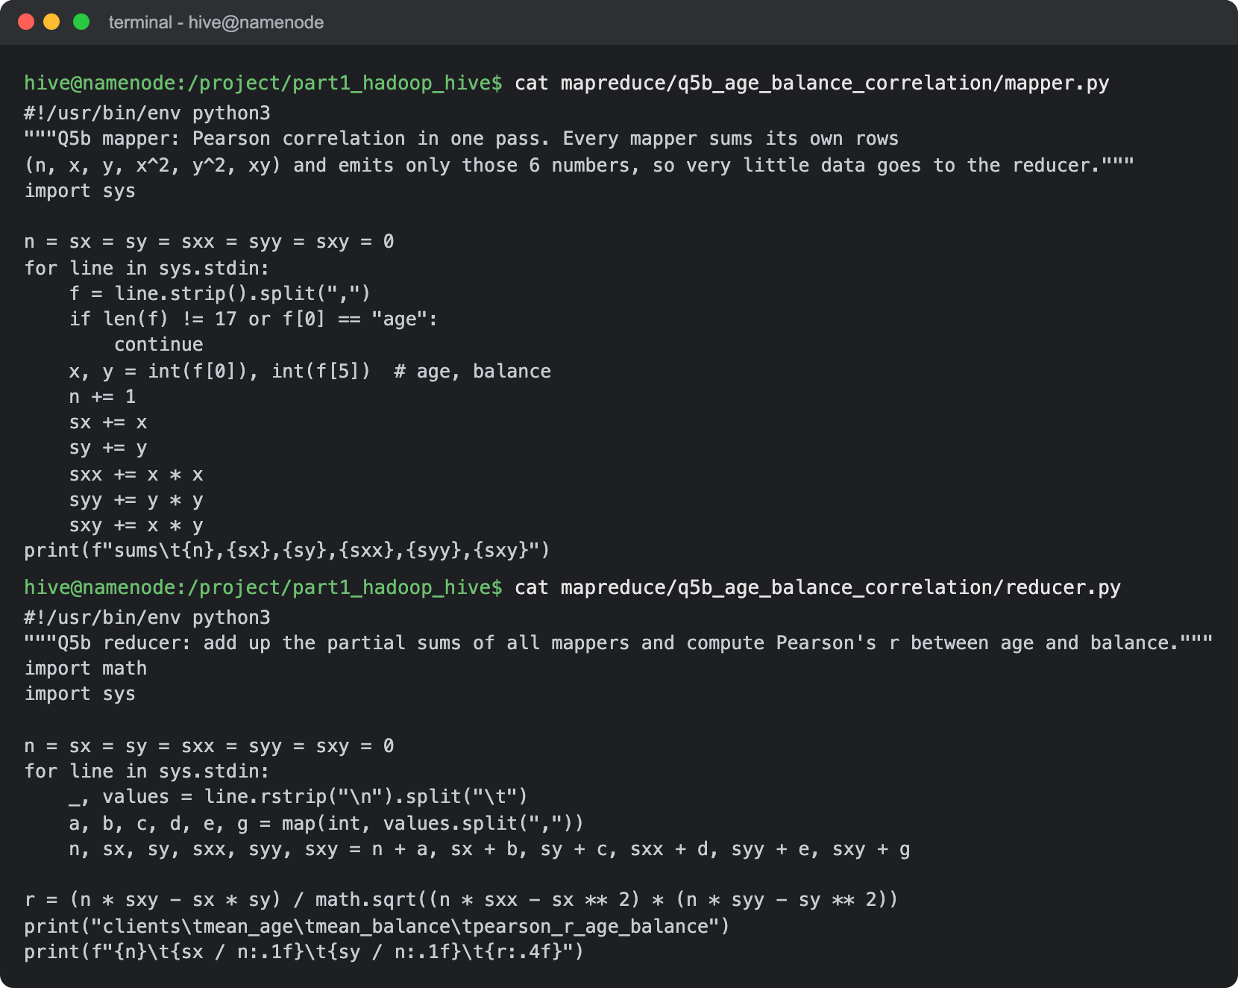
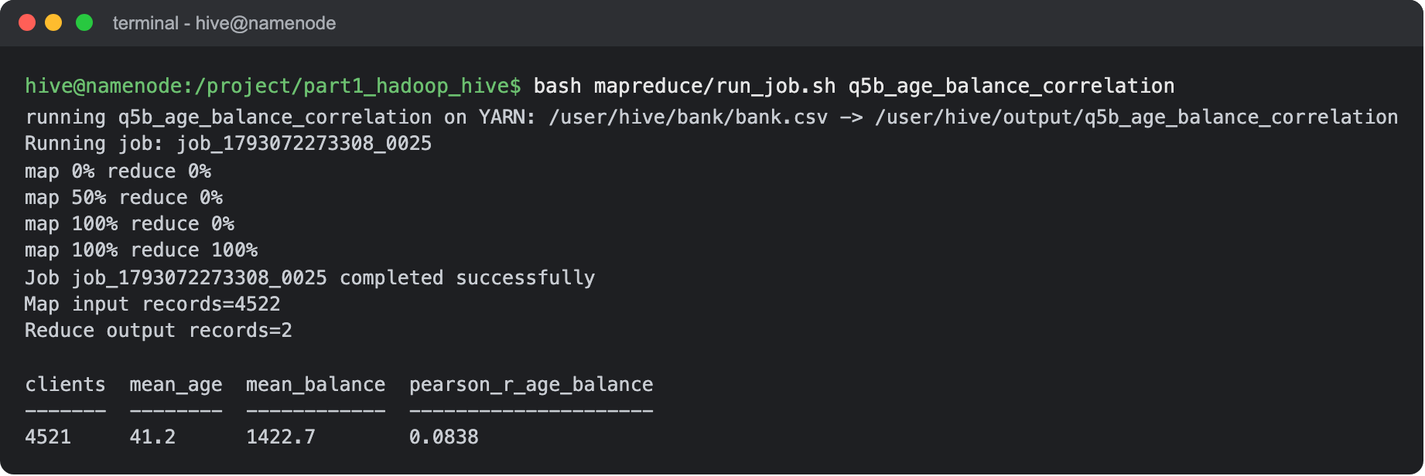
Result: Summary: the balance goes up with age. The average goes from 1,058 (median 353) for clients under 30 to 2,754 (median 847) for clients aged 60 and over, and the oldest group almost never has a negative balance (1.1%). But the second job shows the Pearson correlation is only 0.084, so the relationship is very weak and age explains less than 1% of the differences in balance. The averages are also pulled up by a few very large balances (up to 71,188). For the correlation, each mapper only sends 6 partial sums to the reducer instead of all the rows.

HIVE
- Data Ingestion and Table Creation:
  - Create a Hive database named banking_data.
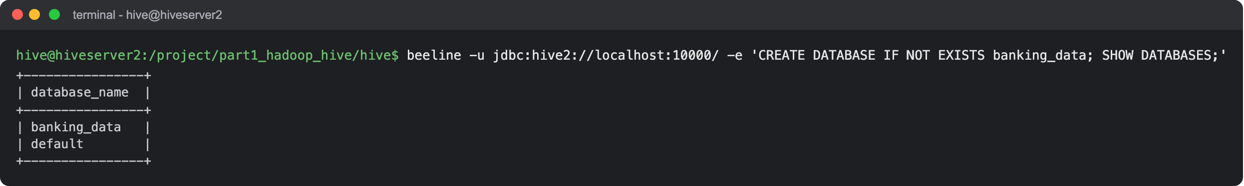
Result: The banking_data database is created and shows up next to the default database.
  - Define and create a Hive table client_info with appropriate data types for the bank.csv dataset.
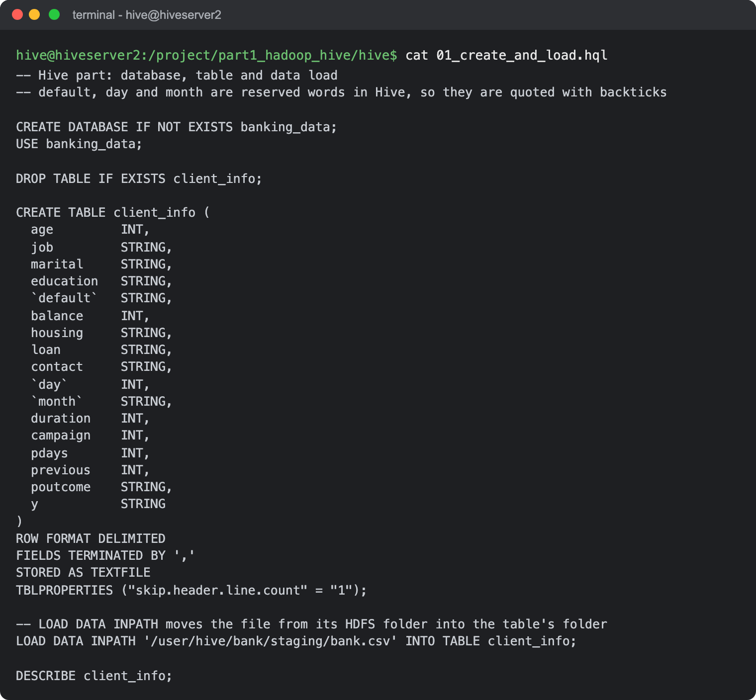
Result: Numeric columns (age, balance, day, duration, campaign, pdays, previous) are INT and the rest are STRING. default, day and month are reserved words in Hive, so they are written in backticks. The header line of the csv is skipped with skip.header.line.count.
  - Load the data from the bank.csv file into the client_info table.
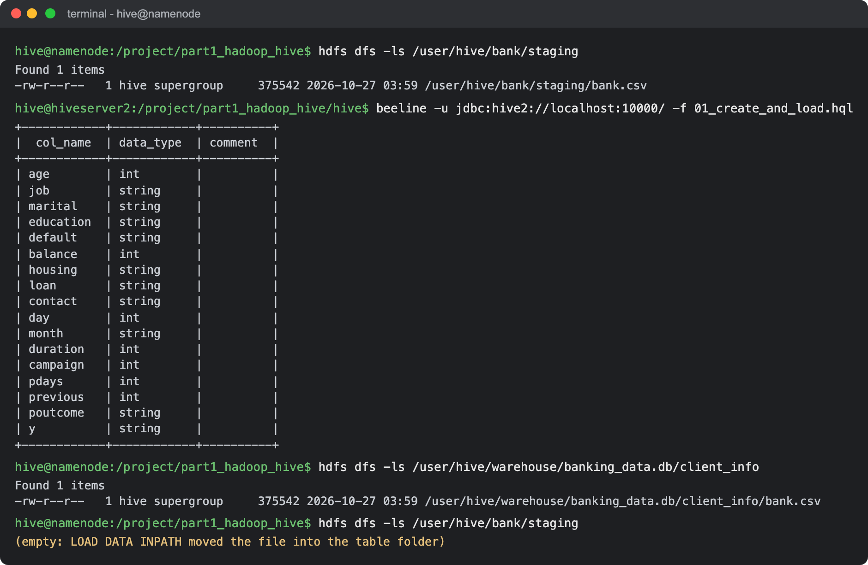
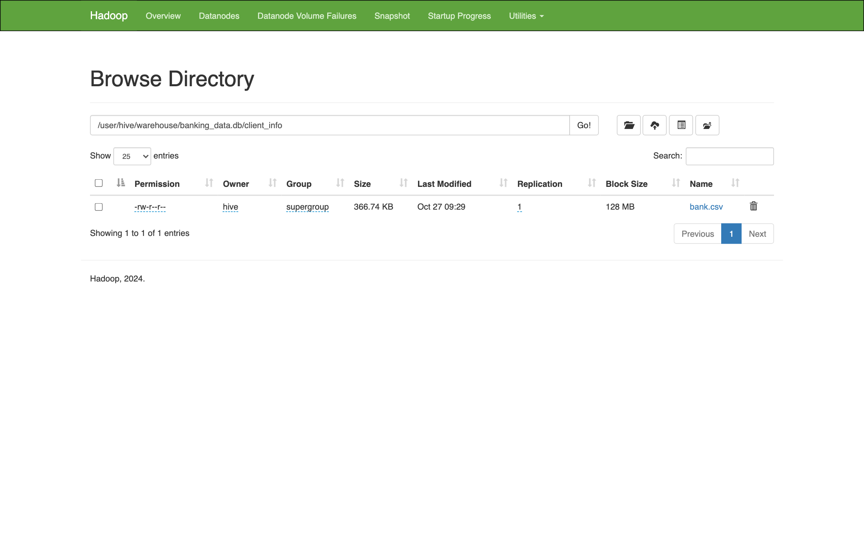
Result: I put a copy of the file in a staging folder in HDFS and loaded it with LOAD DATA INPATH. Hive moves the file into the table's folder in the warehouse (/user/hive/warehouse/banking_data.db/client_info), so the staging folder is empty afterwards.
- Basic Data Exploration:
  - Write a HiveQL query to count the total number of clients in the dataset.
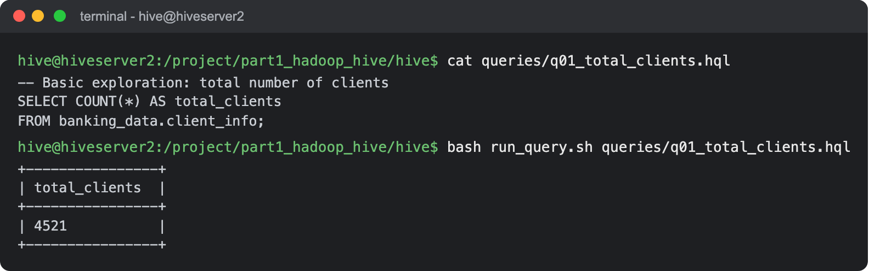
Result: There are 4,521 clients in the table, the same as the number of data rows in bank.csv.
  - Display the first 10 rows of the dataset.
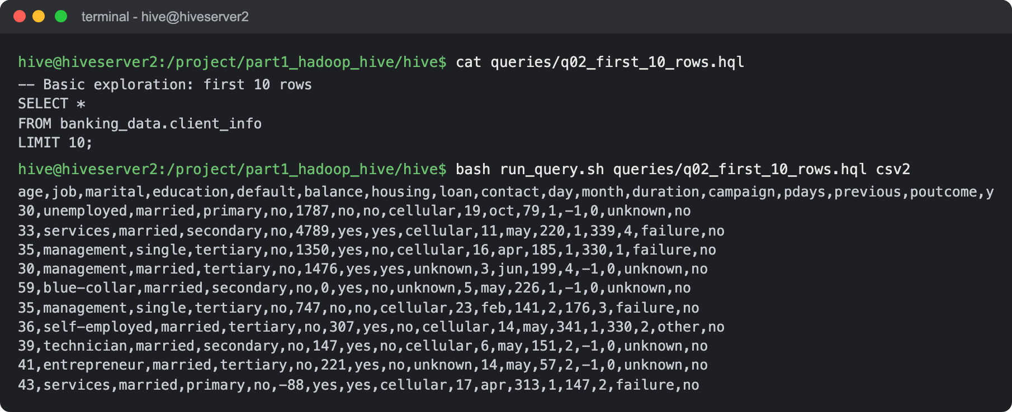
Result: Shown in csv format so all 17 columns fit on the screen.
- Data Filtering and Sorting:
  - Retrieve all records of clients who are married and have a personal loan.
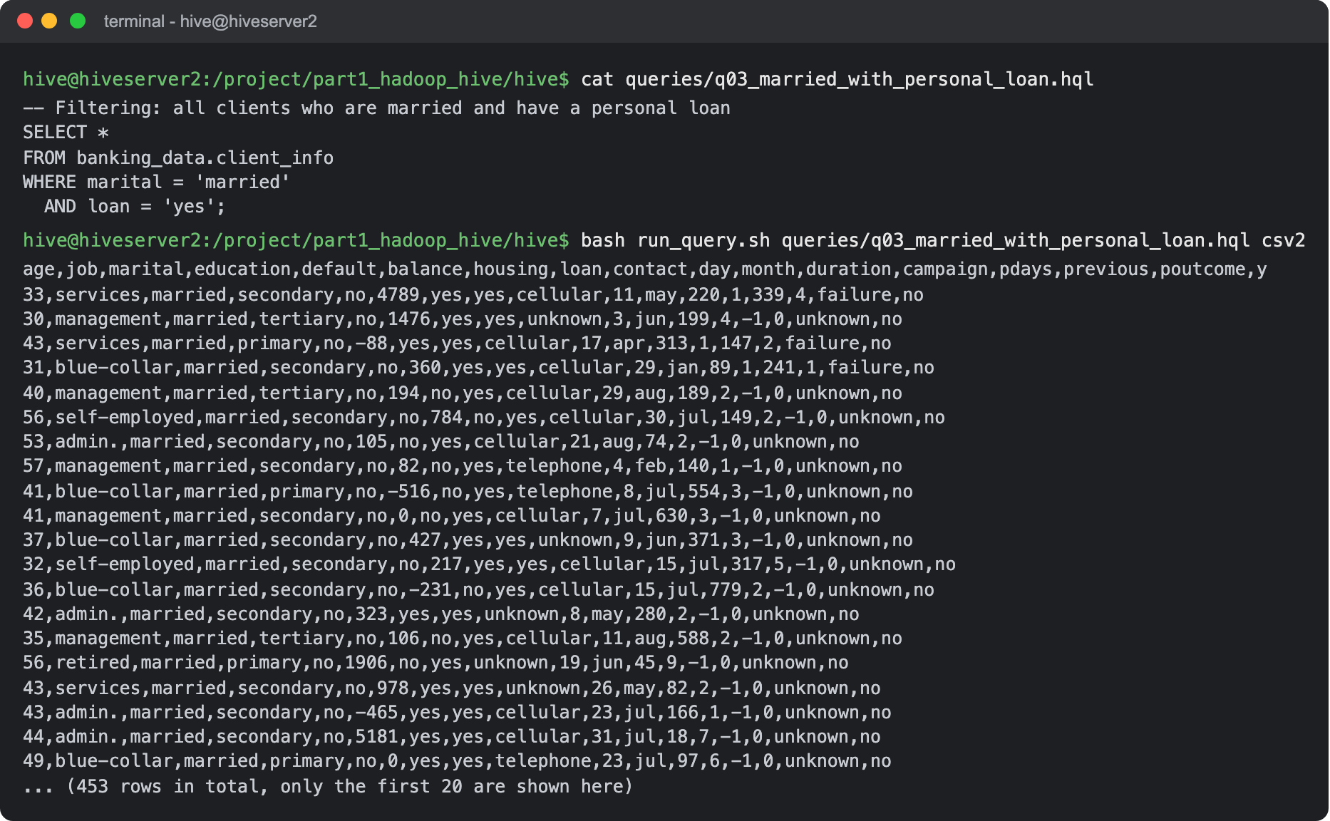
Result: 453 clients are married and have a personal loan. The screenshot shows the first 20 of them.
  - List the top 10 clients with the highest balance, displaying their job, marital status, and balance.
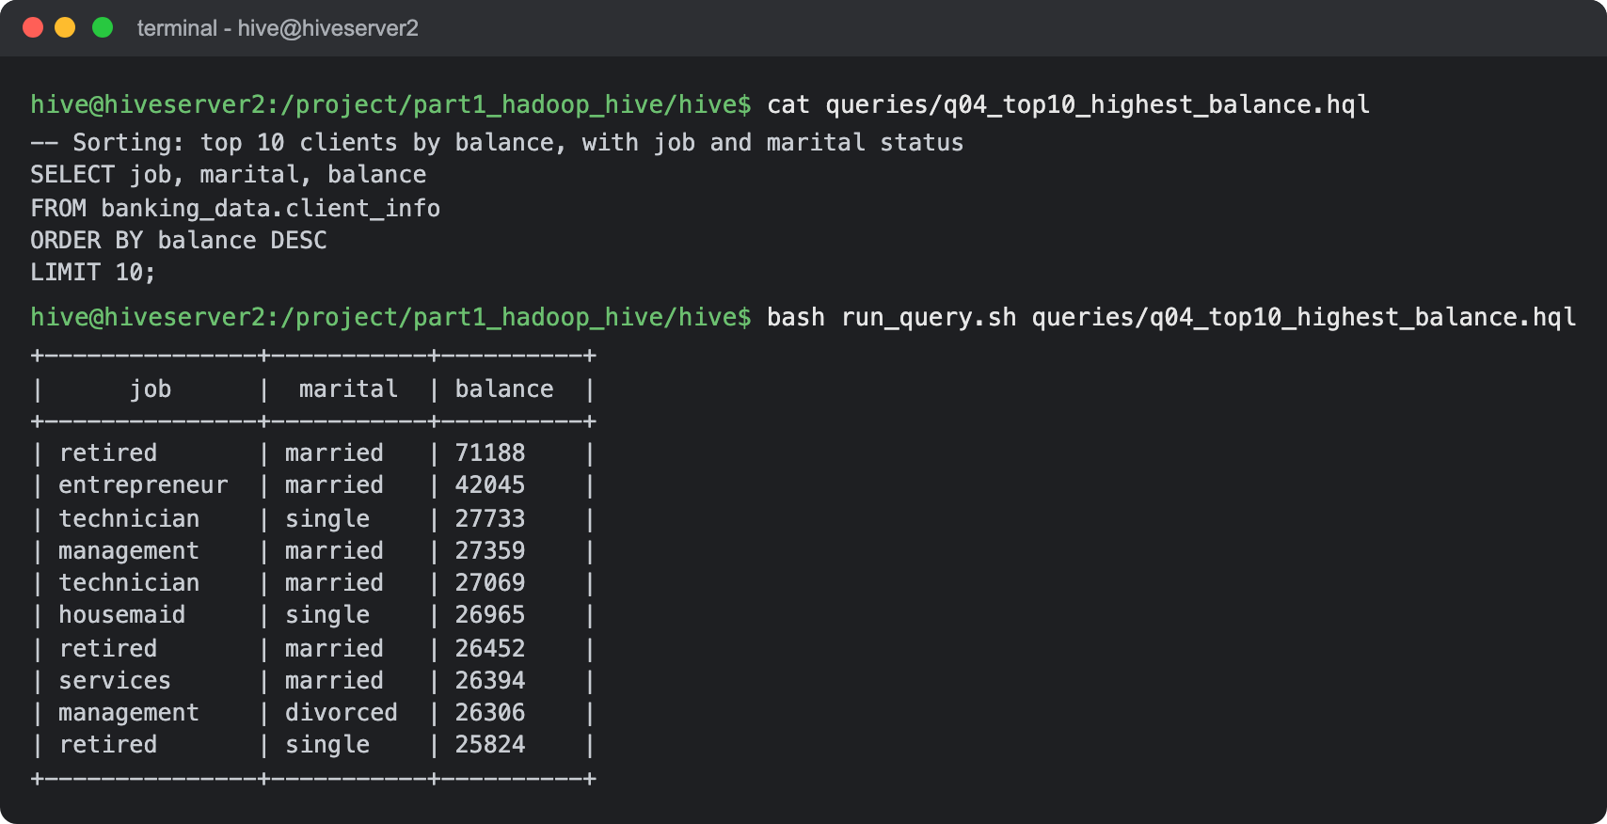
Result: The highest balance is 71,188 (a retired, married client), far above the next one at 42,045 (an entrepreneur). Retired clients appear 3 times in the top 10.
- Data Aggregation and Grouping:
  - Calculate the average age of clients for each job category.
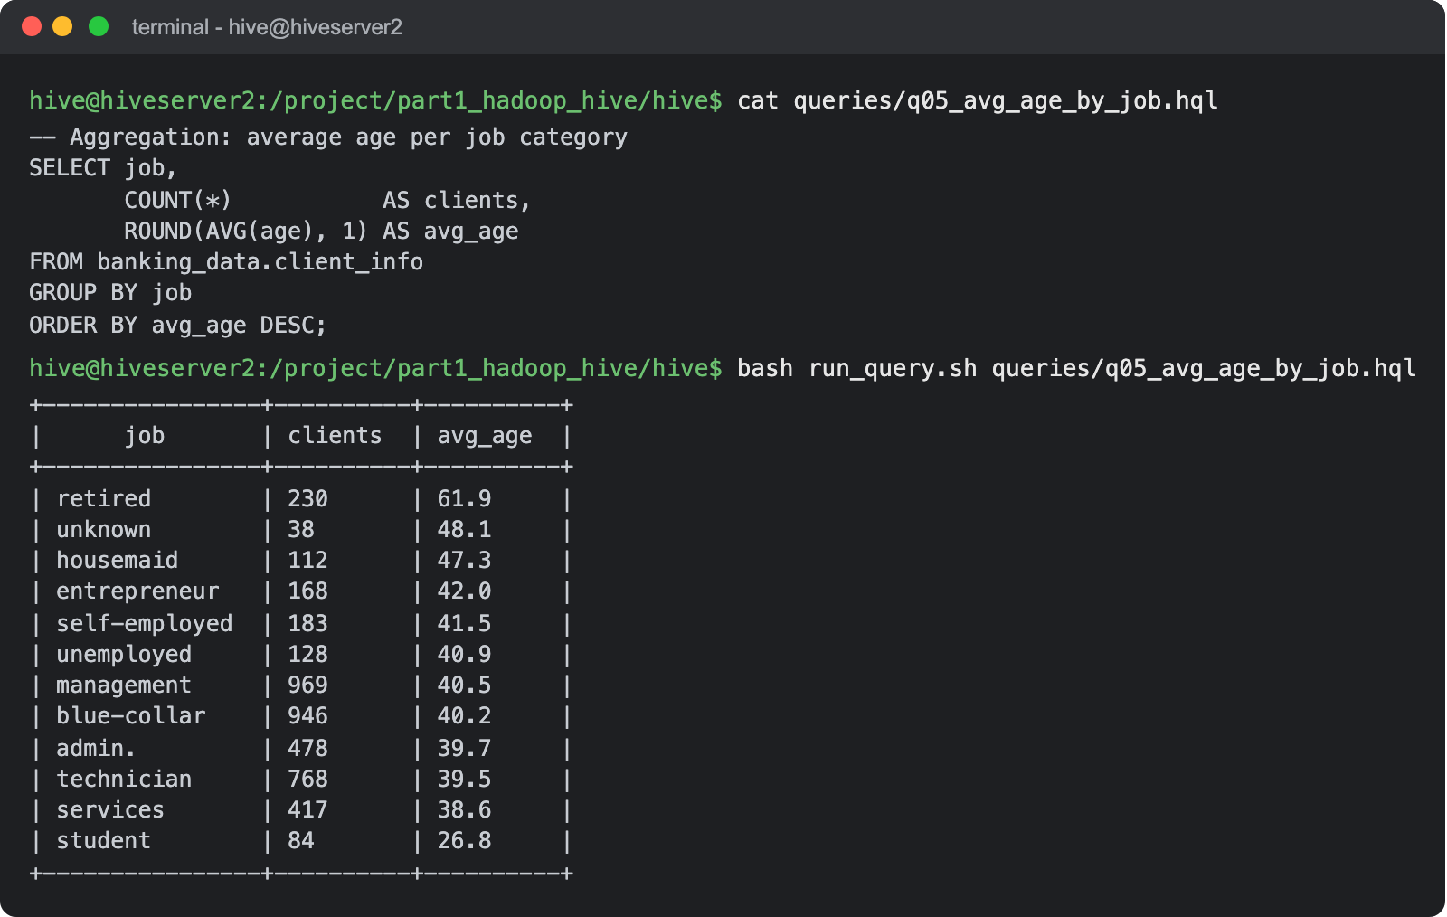
Result: Retired clients are the oldest (61.9 on average) and students the youngest (26.8). Most other jobs are between 38 and 42.
  - Find the total number of clients for each education level who have defaulted on credit.
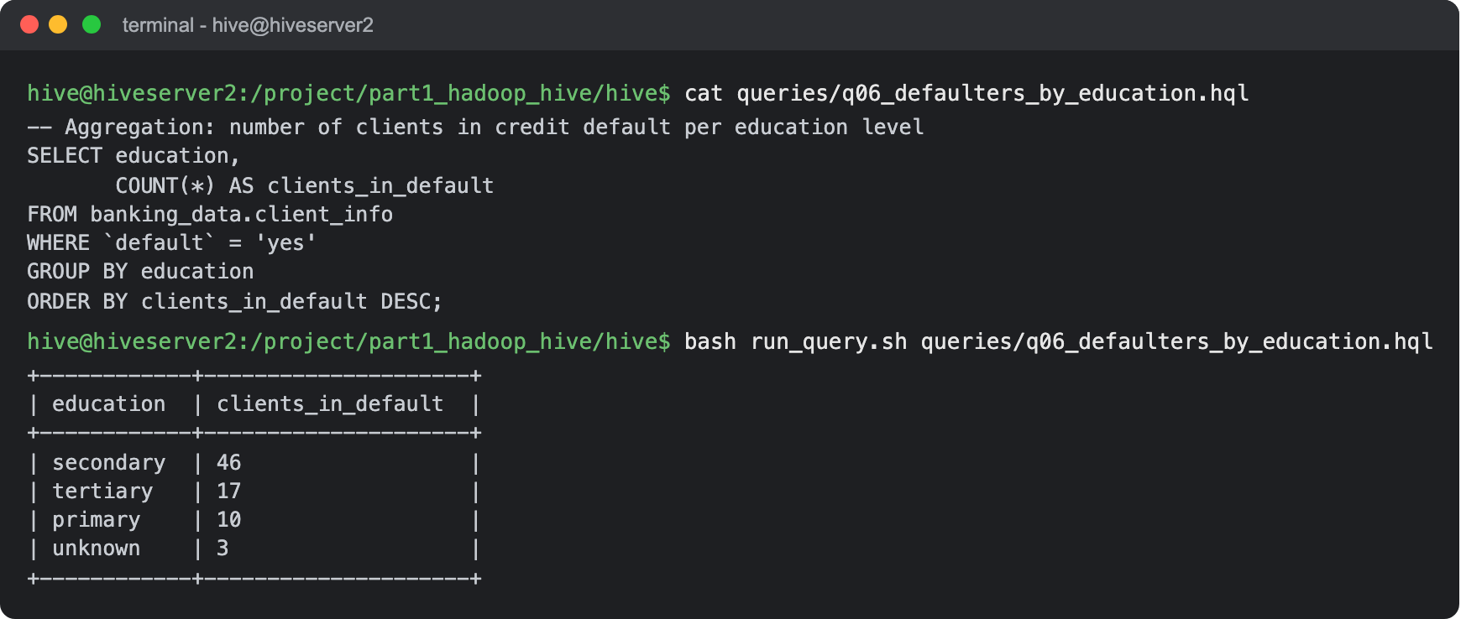
Result: 76 clients are in default: 46 with secondary education, 17 tertiary, 10 primary and 3 unknown. Secondary is also the highest as a share of its group (2.0%, against 1.3% for tertiary).
- Complex Queries for Insights:
  - Identify the top 5 job categories with the highest average balance and the percentage of clients in each of these job categories who have subscribed to a term deposit.
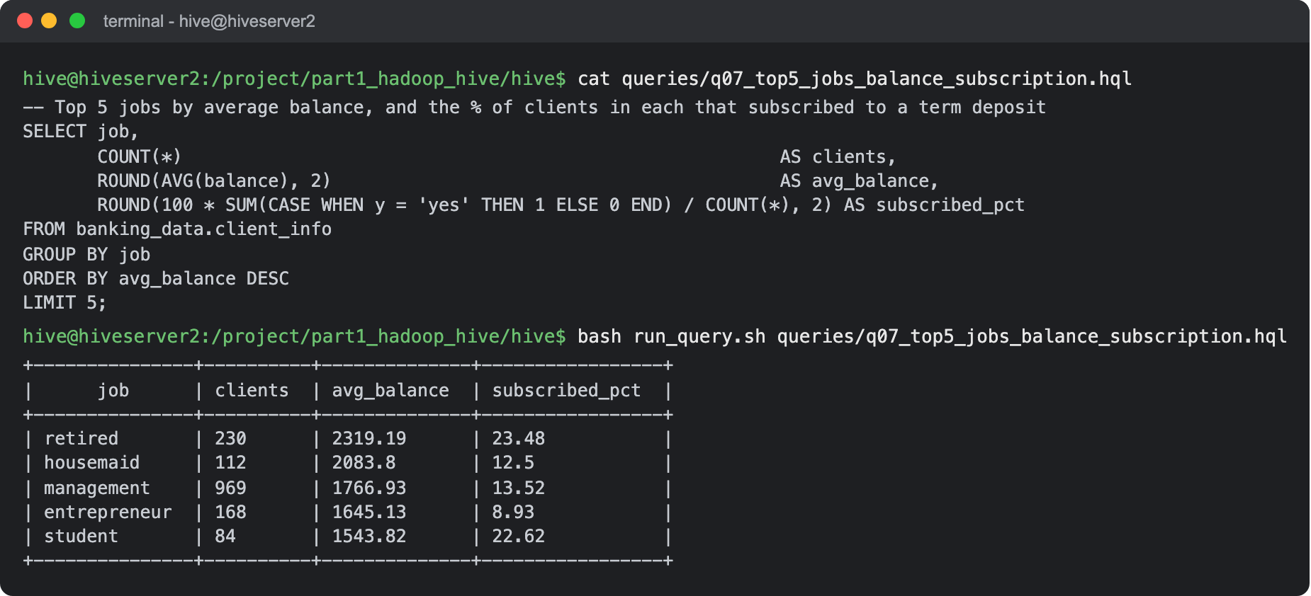
Result: Retired clients have the highest average balance and also the highest subscription rate (23.5%). Students are 5th on balance but subscribe almost as often (22.6%), while entrepreneurs have high balances but the lowest rate of the five (8.9%).
  - Determine the month with the highest number of contacts and the success rate of the campaign in that month (percentage of clients who subscribed to a term deposit).
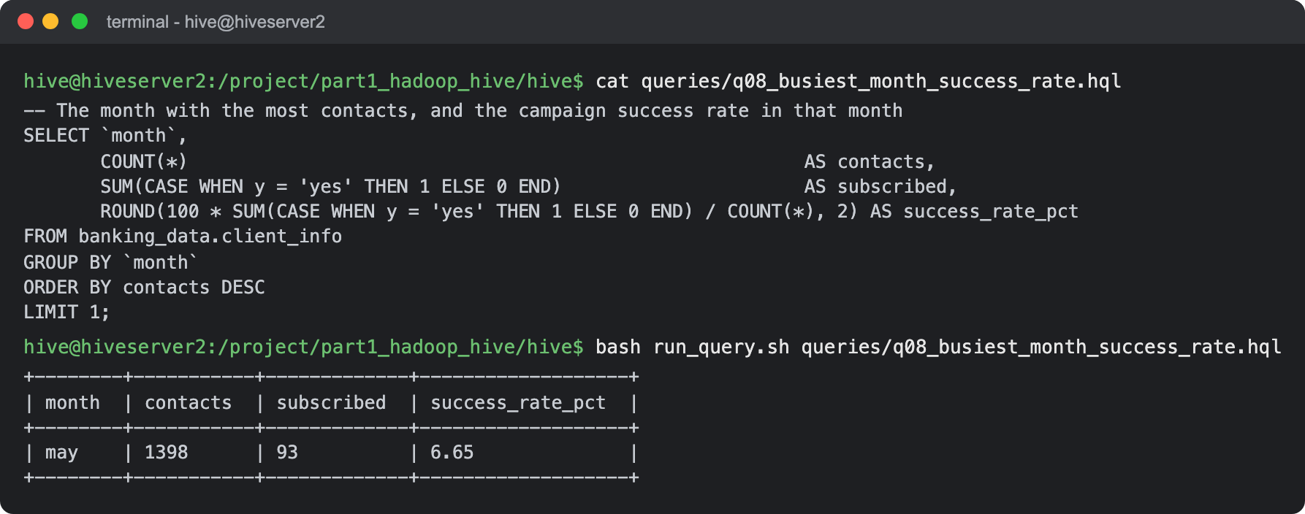
Result: May had the most contacts (1,398) but only 6.65% of those clients subscribed, the lowest rate of any month.
- Correlation Analysis:
  - Calculate the correlation between age and balance for the clients.
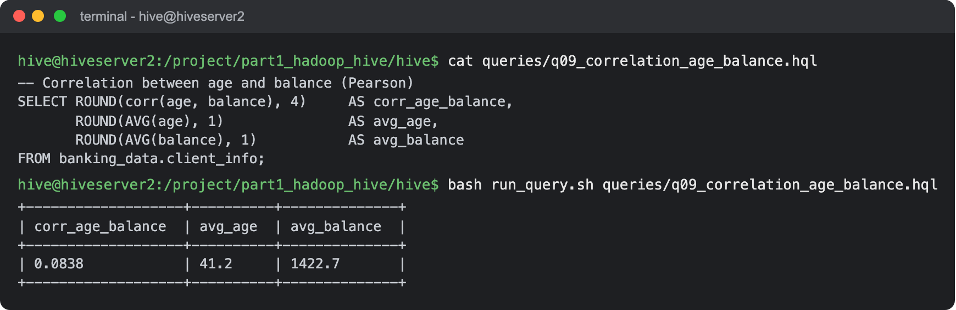
Result: The Pearson correlation is 0.0838, a very weak positive relationship. It is exactly the value my MapReduce job computed, which is a nice check that both are right.
- Trend Analysis:
  - Analyze the year-over-year trend in the number of clients contacted.
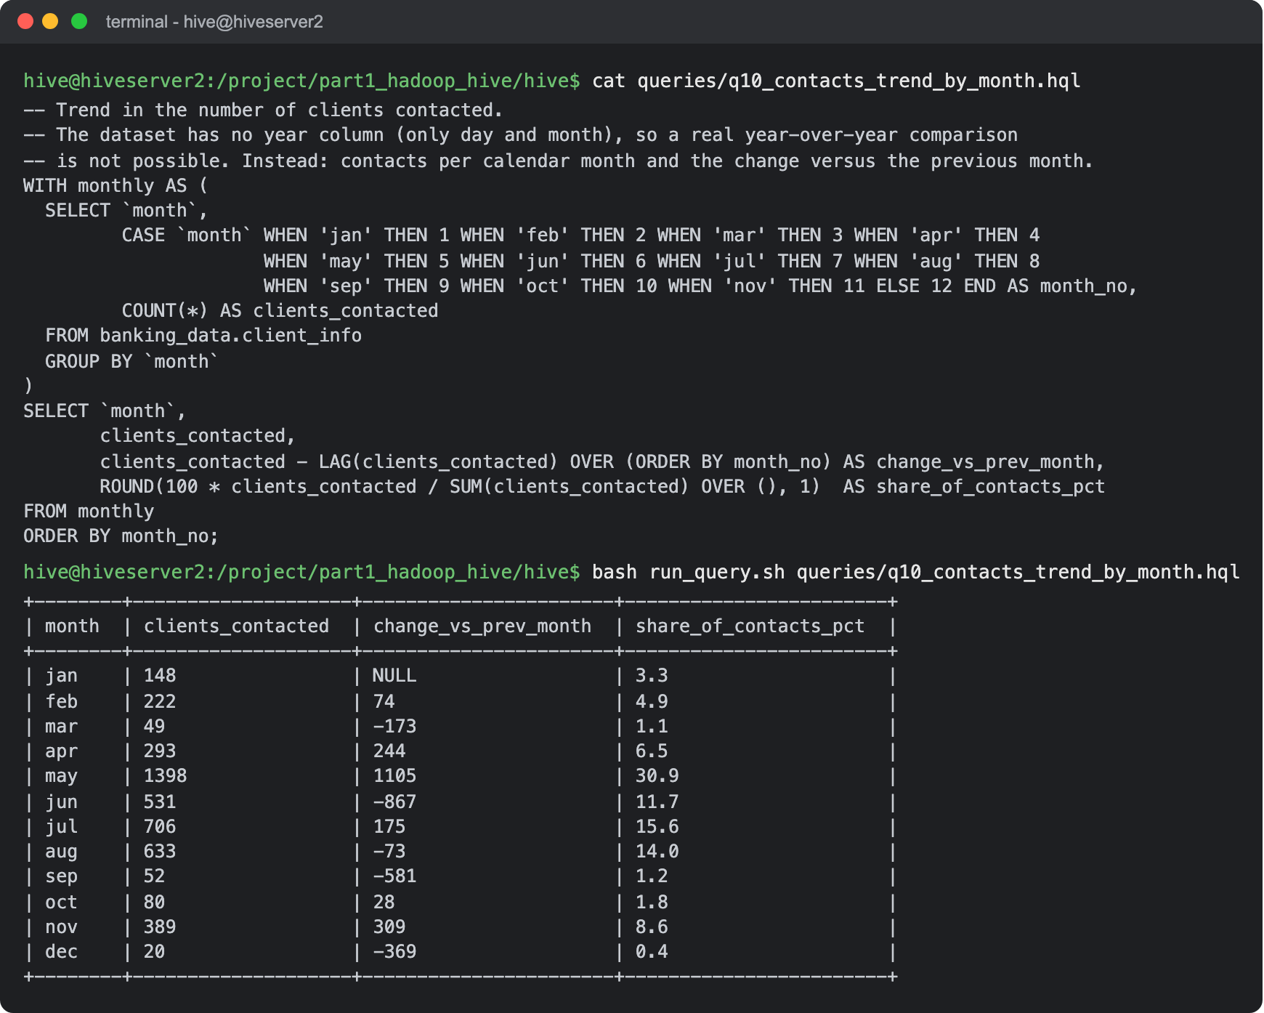
Result: bank.csv has no year column (only day and month), so a year-over-year comparison is not possible with this data. I looked at the trend over the months instead, with the change against the previous month: contacts build up to a big peak in May (31% of all contacts), stay high from June to August, and are low from September to March except for November. The success rate moves the other way, so the bank called the most in the months where it worked worst.
- Anomaly Detection:
  - Identify any unusual patterns in the average yearly balance across different education levels.
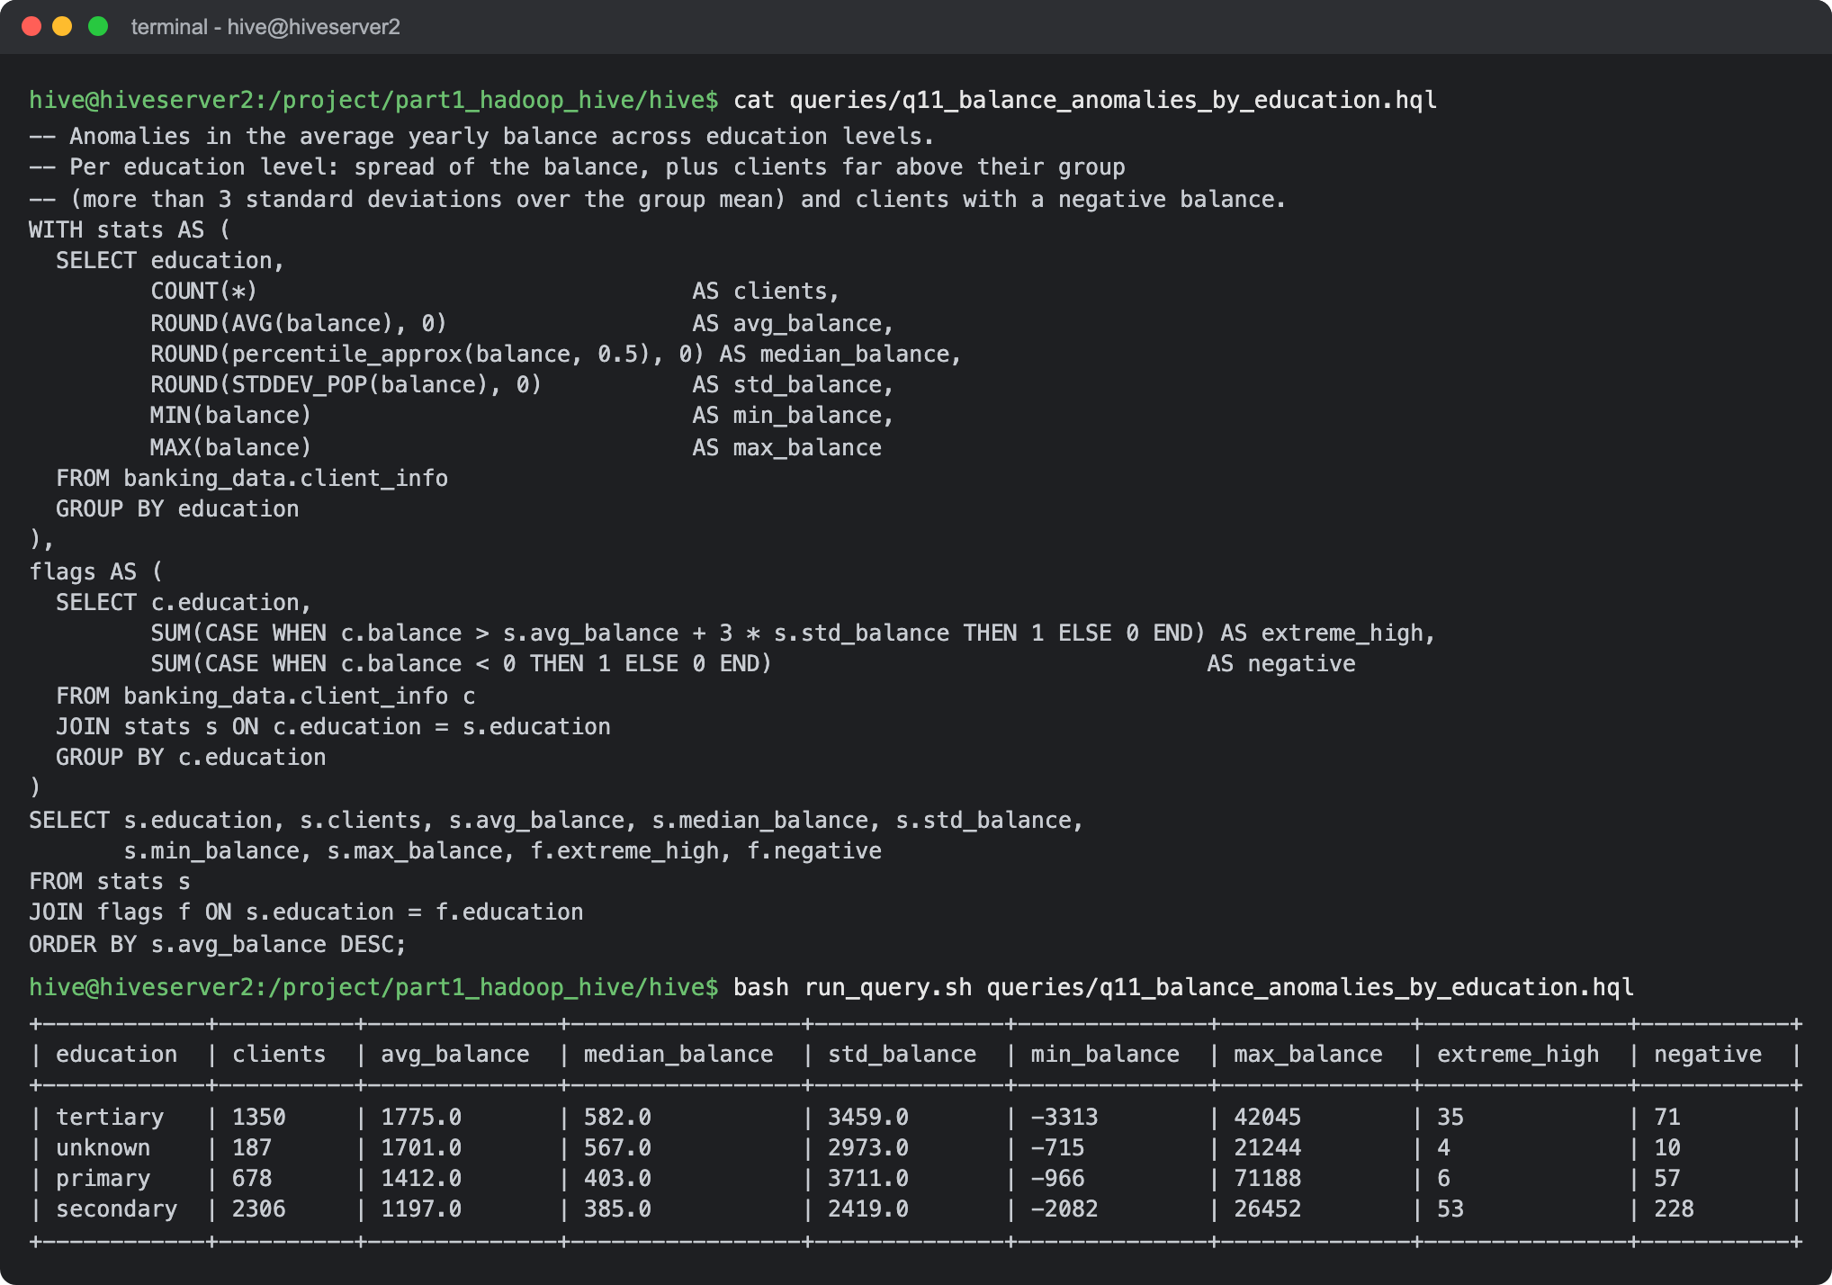
Result: In every education level the average balance is about 3 times the median, so the balances are very skewed by a small number of very rich clients. Primary education stands out: a low median (403) but the highest single balance (71,188) and the largest standard deviation (3,711). Secondary has the most clients far above their group (53 more than 3 standard deviations above the mean) and the most negative balances (228). The lowest balance overall, -3,313, is in the tertiary group.
- Advanced Analysis:
  - Analyze the impact of previous campaign outcomes (poutcome) on the current campaign's success. Calculate the subscription rate (to term deposits) for each poutcome category.
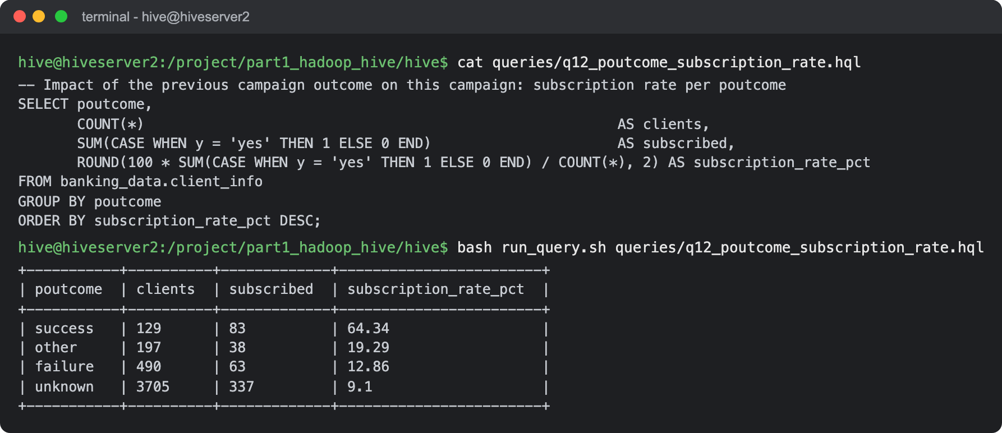
Result: The previous outcome is a very strong signal: 64.3% of clients whose last campaign was a success subscribed again, against 12.9% after a failure and 9.1% for clients who were never contacted before (unknown).
  - Compare the average contact duration for clients who subscribed and who did not subscribe to a term deposit.
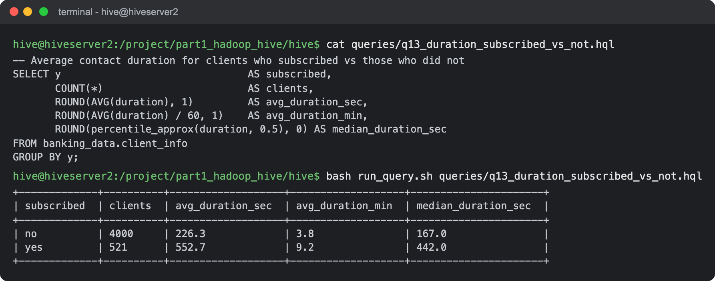
Result: Clients who subscribed talked much longer: 552.7 seconds (9.2 minutes) on average against 226.3 seconds (3.8 minutes). The median shows the same (442 against 167 seconds).

Submission Guidelines:
- Make a copy of this doc file.
- Perform the analysis in your local system using Hadoop and Hive and provide screenshots of both the code and the output under each question.
- Upload the doc file with other files and submit it in the submission dashboard.

